**ПРАКТИЧЕСКОЕ ЗАДАНИЕ 30**

**РАБОТА С БАЗАМИ ДАННЫХ. ТЕХНОЛОГИЯ ADO.NET**

Задание 1 В любой СУБД создайте базу данных DBTur_firm (Структура и описание таблиц базы данных DBTur_firm – стр.18, Схема данных базы DBTur_firm– стр. 21). Для примера рассмотрите создание базы данных в MSSQL Server стр. 22-27. На стр. 28 представлена схема базы данных.

Листинг программы:

{public partial class MainWindow : Window

{public MainWindow()

{InitializeComponent();

SQLiteConnection connection = new SQLiteConnection(@"Data Source=E:\Практика\C#\Practice\PracticeTasks\Practice_30\task1\DBTur_firm.db");

connection.Open();

SQLiteDataAdapter ad = new SQLiteDataAdapter();

SQLiteCommand cmd = new SQLiteCommand();

String str = "SELECT idTour,TourName,TourPrice,TourInfo FROM Tours";

cmd.CommandText = str;

ad.SelectCommand = cmd;

cmd.Connection = connection;

DataSet ds = new DataSet();

ad.Fill(ds);

ListViewDB.ItemsSource = ds.Tables[0].DefaultView;

str = "SELECT idTourists,TouristsLastName,TouristsFirstName,TouristsMidleName FROM Tourists";

cmd.CommandText = str;

ad.SelectCommand = cmd;

cmd.Connection = connection;

DataSet ds1 = new DataSet();

ad.Fill(ds1);

ListViewDBTourists.ItemsSource = ds1.Tables[0].DefaultView;

connection.Close();}

private void Addtour(object sender, RoutedEventArgs e)

{SQLiteConnection connection = new SQLiteConnection(@"Data Source=E:\Практика\C#\Practice\PracticeTasks\Practice_30\task1\DBTur_firm.db");

connection.Open();

SQLiteCommand cmd = new SQLiteCommand(connection);

int idTour = int.Parse(TextBoxAdd.Text.Split()[0]);

string TourName = TextBoxAdd.Text.Split()[1];

int TourPrice = int.Parse(TextBoxAdd.Text.Split()[2]);

string TourInfo = TextBoxAdd.Text.Split()[3];

String str = $"INSERT INTO Tours (idTour, Tourname, TourPrice, TourInfo) VALUES ({idTour}, '{TourName}', {TourPrice}, '{TourInfo}')";

cmd.CommandText = str;

cmd.ExecuteNonQuery();

connection.Close();}

private void DeleteSelected(object sender, RoutedEventArgs e)

{

SQLiteConnection connection = new SQLiteConnection(@"Data Source=E:\Практика\C#\Practice\PracticeTasks\Practice_30\task1\DBTur_firm.db");

connection.Open();

SQLiteCommand cmd = new SQLiteCommand(connection);

String str = $"DELETE FROM Tours WHERE idTour = {Convert.ToInt32(DeleteTextBox.Text)}";

cmd.CommandText = str;

cmd.ExecuteNonQuery();

connection.Close();

}

private void Addtourist(object sender, RoutedEventArgs e)

{

SQLiteConnection connection = new SQLiteConnection(@"Data Source=E:\Практика\C#\Practice\PracticeTasks\Practice_30\task1\DBTur_firm.db");

connection.Open();

SQLiteCommand cmd = new SQLiteCommand(connection);

int idTourist = int.Parse(TextBoxAddTourist.Text.Split()[0]);

string TouristsLastName = TextBoxAddTourist.Text.Split()[1];

string TouristsFirstName = TextBoxAddTourist.Text.Split()[2];

string TouristsMidleName = TextBoxAddTourist.Text.Split()[3];

String str = $"INSERT INTO Tourists (idTourists,TouristsLastName,TouristsFirstName,TouristsMidleName) VALUES ({idTourist}, '{TouristsLastName}', '{TouristsFirstName}', '{TouristsMidleName}')";

cmd.CommandText = str;

cmd.ExecuteNonQuery();

connection.Close();

}

private void ChangeById(object sender, RoutedEventArgs e)

{

SQLiteConnection connection = new SQLiteConnection(@"Data Source=E:\Практика\C#\Practice\PracticeTasks\Practice_30\task1\DBTur_firm.db");

connection.Open();

SQLiteCommand cmd = new SQLiteCommand(connection);

int idTourist = int.Parse(ChangeTextBox.Text.Split()[0]);

string TouristsLastName = ChangeTextBox.Text.Split()[1];

string TouristsFirstName = ChangeTextBox.Text.Split()[2];

string TouristsMidleName = ChangeTextBox.Text.Split()[3];

String str = $"UPDATE Tourists SET TouristsLastName = '{TouristsLastName}', TouristsFirstName='{TouristsFirstName}', TouristsMidleName='{TouristsMidleName}' WHERE idTourists = {idTourist};";

cmd.CommandText = str;

cmd.ExecuteNonQuery();

connection.Close();}}}

Анализ результатов:

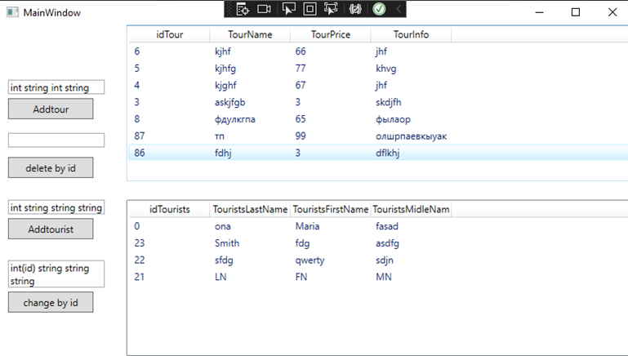

Рисунок 30.1 – Результат работы программы

Источник: собственная разработка